How to Achieve Consistency & Control in Future Dating

Presenting The Case

Introduction
The title of this document may be taken as both a question and a statement. It is a question because it echoes a requirement reiterated throughout the BRDs that does not yet have a coherent solution. It is a statement because this document outlines a solution that lies in expanding the role of the Space, Range and Merchandising Schedule from simply a vehicle for communicating range change dates to CRST to a key controlling hub that is central to the business process.

Requirements
The following business requirements all tie future-dating firmly to the Space, Range and Merchandising Schedule:
BRD 1
- The planned merchandising group structures used in CRST for ranging must be strictly in accordance with the timings set out in the Merchandising Schedule.
- The effective date for a link (Main Merch Groups & Subgroups) must correspond with the effective date of a change to the range or ranges affected by this link (as defined by the Merchandising Schedule).
- The effective date for a link (Subgroups & Products) must correspond with the effective date of an associated change to the range or ranges affected by this link (as defined by the Merchandising Schedule).
- The effective date for a link (Express, Promotional / Seasonal Merchandising Groups & Products) must correspond with the effective date of an associated change to the range or ranges affected by this link (as defined by the Merchandising Schedule).

BRD 2
- Capability to control change by linking future infrastructures to events on the Space, Range and Merchandising schedule so that new infrastructures become operational at the same time as the ranges that were built on them.
- Creation of new Store Clusters that will be used to define the ranges for a merchandising group will only be allowed in line with the dates on the Merchandising Schedule.

BRD 3
- The implementation date of a range change for a Merchandising Group can vary by store cluster (e.g. Superstores in England & Wales one week; Superstores in Scotland two weeks later; Extras on another date).
- If the dates or other information about a range change are altered it must still be possible to identify that range change.

The Problem
None of the solutions are at present addressing the problem of controlling the co-ordination of future-dating requirements across store cluster / merchandising group links, supported space breaks and equipment types, main merchandising group to subgroup links and Express / Promotional / Seasonal and product links. If dates are maintained separately to satisfy every different requirement, their maintenance, should changes occur, will be an unwieldy and error-prone overhead, with possible chaotic consequences.
To hold dates separately to satisfy every different requirement goes against the rules of data normalisation. Scheduled implementation dates should not be repeated in a profligate manner across the Range ODS, GR, CW and any other system that requires to use them; they should be held in one place only (the Schedule) and maintained independently of the range changes they chronicle. In this way they can be a controlling factor, rather than merely disseminated information that can become out of date.

A Solution
The second requirement listed from BRD 3 is a clue to how the problem might be solved. Each scheduled range change requires a unique identifier that is independent of the dates, for example, ‘New Spring Plan for Meat’ or ‘September Plan for Bakery’. Screens that will be designed in BSD 1 and BSD 2 will be able to reference specific range changes by reading the Schedule using their unique identifiers; dates will be displayed for information, but the user will not enter them. The unique identifiers for range changes, which will remain constant, rather than dates, which may not, will be stored in dependent systems. This will give several key benefits:
- Implementation dates will be consistent across the whole of Space, Range and Merchandising.
- References to scheduled range changes will remain the same even though implementation dates change.
- Any change to implementation dates will be immediately effective across all relevant systems.
- Implementation dates can be easily maintained independently for different store clusters within a strategy. The link between a strategy and a merchandising group (see BSD 2) will not be date-based, but will be based on the unique identifier of the forthcoming range change, which may encompass different dates for each of the store clusters involved.
- The need for a considerable amount of complicated date processing in Pre-Ranging Activities and Merchandising and Subgroup Maintenance is removed.
- The authorisation, release and implementation of changes to store clusters, merchandising group hierarchies and the ranges based on them will be synchronised and completely controllable from the Schedule, allowing no possibility of stores with no ranges or ranges with no stores to go to, or inconsistencies between products in merchandising groups in CW and products in ranges in the ODS.

Using Future Dates

Levels of Future-Dating
Future-dating may be applied on two levels:
- To define the infrastructure, or framework, on which the range will be built
- To map individual stores to the framework.

Infrastructure Dates
This level of future-dating must be tied to the schedule under all circumstances. Specifically:
- Definition of how the range will be structured:
- Merchandising group links to store clusters
- Supported space breaks and equipment types
- Definition of the products in the range:
- Subgroup links to main merchandising groups
- Product links to subgroups
- Main merchandising group links to supplementary merchandising groups
- Product links to Express merchandising groups

Store Mapping Dates
Other future-dating may be applied between range changes, to reflect changes that may occur independently of range changes, and simply results in stores mapping to a different existing range or plan. Specifically:
- Definition of stores in each cluster:
- Store ranging attributes
- Store merchandising group ranging attributes
- Definition of stores to receive overlays:
- Store merchandising group overlays
- Definition of space / equipment available in stores
- Store merchandising group space break / equipment type
However, all these changes are controllable from the centre; the only one of these changes that can be initiated by the store is a change of space, and this is completely outside the scope of pre-ranging activities. Therefore, although there is no theoretical reason why a store might be changed, for example, from Midmarket to Affluent for Confectionery, or given an extra overlay for Cheese, between range changes, the question must be asked, ”Is there a justifiable business reason for doing this?”. The level of change in each store is much more controllable if everything that causes a range change for stores is co-ordinated through the Schedule.

Control Through the Schedule
The Space, Range and merchandising Schedule will hold the dates for three types of range change:
- New Merchandise Plan
- Updated Merchandise Plan
- Refresh
It is assumed that Out of Cycle changes, though not on the schedule, will not cause any product movement between subgroups or merchandising groups or changes to store clusters or overlays.
Control is greatly simplified if all future date requirements described above can be driven from the Schedule and referenced by the unique identifier of the range change involved.
Required: A decision from the business that overlays and store clusters will not be modified between scheduled range changes.

Timing and Control of Future-Dated Changes

Process Dependencies
When CRST is loaded with the data required to range a merchandising group, performance data is aggregated based on the store clusters and merchandising group / product hierarchy that have been defined for the implementation date of the range. Once this data load has taken place, the store clusters, aggregated performance data and merchandising group / product hierarchy in CRST must not be changed without a new data load, which would obliterate any ranging work that might have been done up to this point.
The ranging process is illustrated, at a high level, in the following diagram:

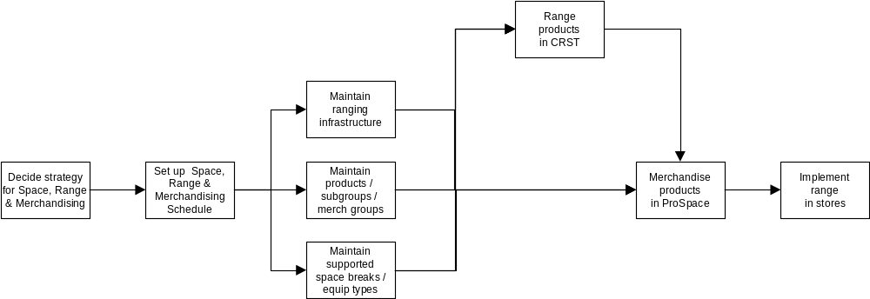

It is clear from this diagram that the infrastructure is carried forward in the process on two paths: one through CRST and the other through merchandising. CRST is loaded with a snapshot copy of the infrastructure, whereas any changes that might be made will be visible to merchandising. Unless the infrastructure is frozen for the duration of the current range change, there will be a breakdown in communication between CRST and merchandising and the ranges from CRST will not be implementable. It follows that there must be tight control over when the infrastructure can be changed and when it cannot.
Changes to the infrastructure after the start of CRST ranging could have the following impacts:
- Changes to the store clusters linked to a merchandising group will create a mis-match between clusters and ranges, which could result in no stores having a range. For example, if ranging in CRST were based on a single cluster for the whole of the UK, and then a separate cluster were created for Scotland to become effective on the same date as the new range, the original cluster would cease to be linked to the merchandising group, being replaced by the two new clusters (one for England, Wales and N. Ireland and the other for Scotland) for which no ranges would have been created. The stores, too, would cease to be linked to their former clusters and would lose their previous range without there being a new range to replace it.
- Changes to the subgroups in a merchandising group (and possibly movements of products between subgroups) will result in a mis-match between the views of the products in a merchandising group held in CW / Product ODS and the Range ODS. This will have an adverse impact on Retail Range, SSPOGS and GR.
- Changes to the supported space breaks will require revision of ranging decisions made so far. For example, if there are any smaller supported space breaks than before, there will have been no ranges created for them.
Changes to the way stores map to the infrastructure could have the following impacts:
- Changing the ranging attributes for a store or store merchandising group could make a store map to a different cluster, causing the sales aggregations in CRST to no longer accurately reflect the ‘To Be’ without a complete reload.
- Changes to store space breaks will cause a change to the store count by space break in CRST.
- Changes to the overlays for store merchandising groups will have no impact on CRST, but will have an impact on autostocking in CR if the range has been authorised.
- Changes to the overlays permissible for a specific merchandising group may cause validation errors in CRST if they have already been used.

Control Through the Schedule
When an infrastructure has been set up in preparation for ranging, in accordance with an Event on the Space, Range and Merchandising Schedule, and is made available to other systems, such as CRST and ProSpace, no further maintenance should be carried that is connected to that Event on the Schedule until the new range has been authorised. This is to ensure that the infrastructure on which the range is built remains stable and consistent throughout the ranging process.
The ability to make updates related to a specific Event on the Space, Range and Merchandising Schedule is required to be controlled by the status of the scheduled Event, which will be modified at significant stages in the ranging process. Before activity begins for an Event, its status will be ‘Open’. The cycle of status changes during ranging will be as follows:
Before | Process Stage | After
Open | Infrastructure Maintenance | Pending
Pending | CRST Data Load | Locked
Locked | Range Cancellation | Open
Locked | Range Authorisation | Authorised
Authorised | Range Cancellation | Open
Authorised | Range Implementation | Authorised

A separate status will be held for each scheduled range change for each merchandising group. This will allow updates that might affect the current range change to be blocked, while still allowing updates for the subsequent range change to proceed.
If the status is anything other than ‘Open’, users will be prohibited from updating any part of the infrastructure that is controlled by dates, i.e.:
- Store ranging attributes
- Store merchandising group ranging attributes
- Relationships between merchandising groups and store range group strategies
- Movement of products between subgroups
- Movement of subgroups between merchandising groups
- Main merchandising groups in supplementaries
- Supported space breaks and equipment types
- Changes planned by the Centre to store range classes
Note:
- The setting of the status from ‘Open’ to ‘Pending’ depends on the conclusion of 3 separate activities in 3 separate systems (Pre-Ranging, CW and Range to Space). This status setting will therefore require a second level of control i.e. a subsidiary status for each separate system.
- The change of status of a scheduled event from ‘Pending’ to ‘Locked’ is dependent on functionality in the CRST data load process.
- If the ranging process is aborted for any reason, even after authorisation, or needs to be restarted, Ranges In Progress will set the status of the ‘in progress’ range to ‘Cancelled’, which will cause the scheduled event’s status to be reset from ‘Locked’ or ‘Authorised’ to ‘Open’.

The diagram on the following page illustrates how the status of a merchandising group can be changed at critical points in the ranging process.
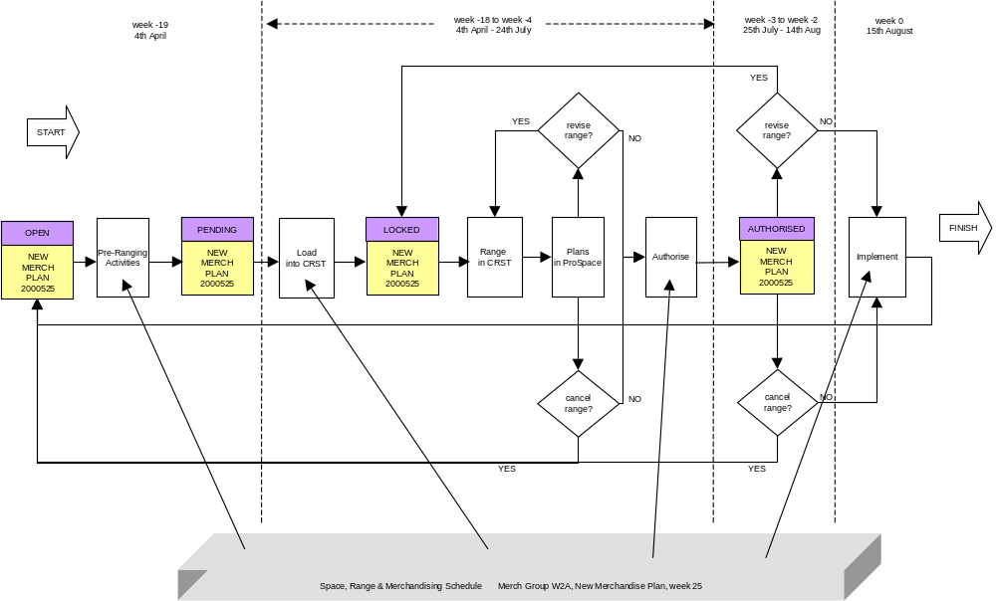

Control by Lead Time
A further restriction will be applied by the lead time specified on the Space, Range and Merchandising Schedule for the upcoming Event. The lead time will be based on the number of weeks between starting ranging in CRST and the effective date of the range (typically this will be 18 weeks for a New Merchandise Plan and 6 weeks for an Update or a Refresh). No changes will be permitted for normal users within this lead time. However, a user identified as one with Override status will be permitted to make changes within this lead time, but still with the proviso that the status is ‘Open’.

